Longford Village Hall Hirers’ COVID-19 Risk Assessment | 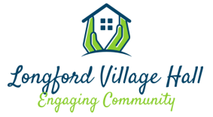

Name/Organisation of Hirer:
Date of Assessment:

This risk assessment must be completed before hire of the Hall and emailed to the Committee (lvh.friends@gmail.com). Your booking will remain provisional until your risk assessment is approved.
A copy of the Standard Risk Assessment and the additional Covid-19 Risk assessment are available on the Covid-19 page on our website.
Area of Risk | Risk Identified | Actions Taken to Mitigate Risk | Notes

Assessed by:
Approved by:
Date:

